Ex.No: 6b | DATA VISUALIZATION USING TABLEAU

AIM:
To connect, analyze, visualize, and create interactive dashboards using Tableau for effective business intelligence and data analytics.

ALGORITHM:
Connecting Data Source
Step 1 Open Tableau Desktop
Step 2 Select Connect
Step 3 Choose Excel File
Step 4 Browse Dataset
Step 5 Open Dataset
Step 6 Verify Imported Data

Algorithm – Sheet 1: Follower Count by Platform
Chart: Bar chart
1. Open the Social Media Engagement dataset in Tableau.
2. Create a new worksheet named Sheet 1.
3. Drag Platform to the Columns shelf.
4. Drag Follower Count to the Rows shelf.
5. Tableau automatically aggregates Follower Count using SUM or Average.
6. Select the Bar chart from the Show Me panel.
7. Format the chart and display platform names.
8. Compare follower counts across different platforms.
9. Use labels to identify the values.
10. Analyze the relationship between Platform and Follower Count.
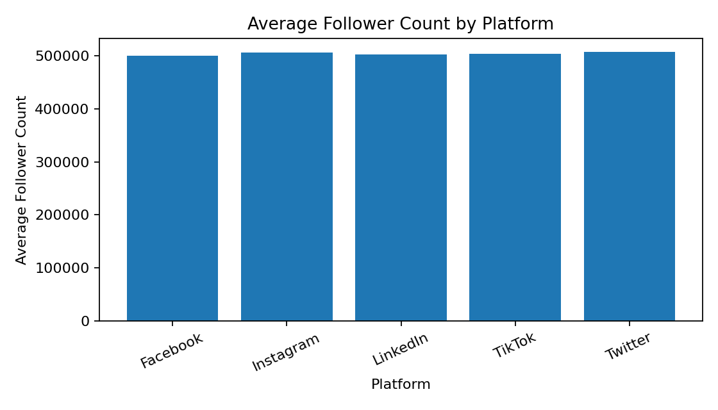

Algorithm – Sheet 2: Engagement Rate by Platform
Chart: Line chart
1. Create a new worksheet named Sheet 2.
2. Drag Platform to the Columns shelf.
3. Drag Engagement Rate to the Rows shelf.
4. Tableau calculates the aggregated Engagement Rate.
5. Select the Line chart from the Show Me panel.
6. Generate a line showing engagement-rate patterns across platforms.
7. Add labels or filters if required.
8. Compare engagement rates across platforms.
9. Identify platforms showing higher or lower engagement patterns.
10. Use the visualization to understand the relationship between Platform and Engagement Rate.
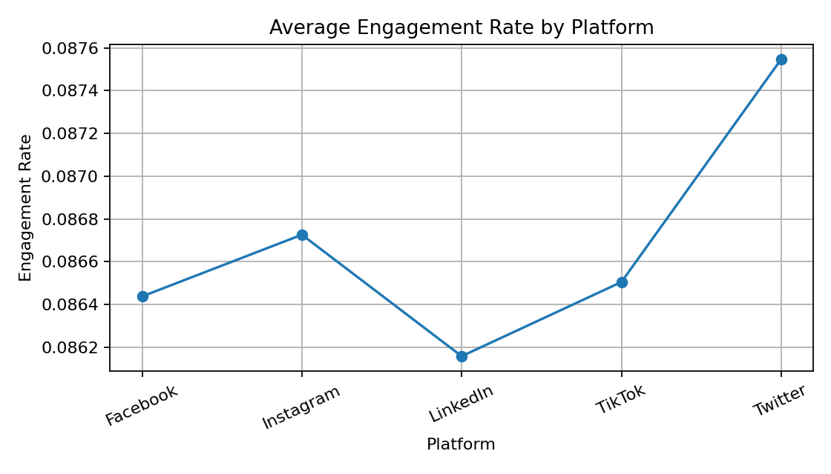

Algorithm – Sheet 3: Follower Count Distribution
Chart: Histogram / Bar chart
1. Create a new worksheet named Sheet 3.
2. Select the Follower Count field.
3. Create Follower Count Bins to group accounts into ranges.
4. Place Follower Count (bin) on the Columns shelf.
5. Place Follower Count on the Rows shelf.
6. Change the aggregation to COUNT(Follower Count).
7. Select the Bar chart.
8. Display the number of accounts in each follower-count group.
9. Compare the frequency of different follower-count ranges.
10. Identify the follower-count range having the highest number of accounts.
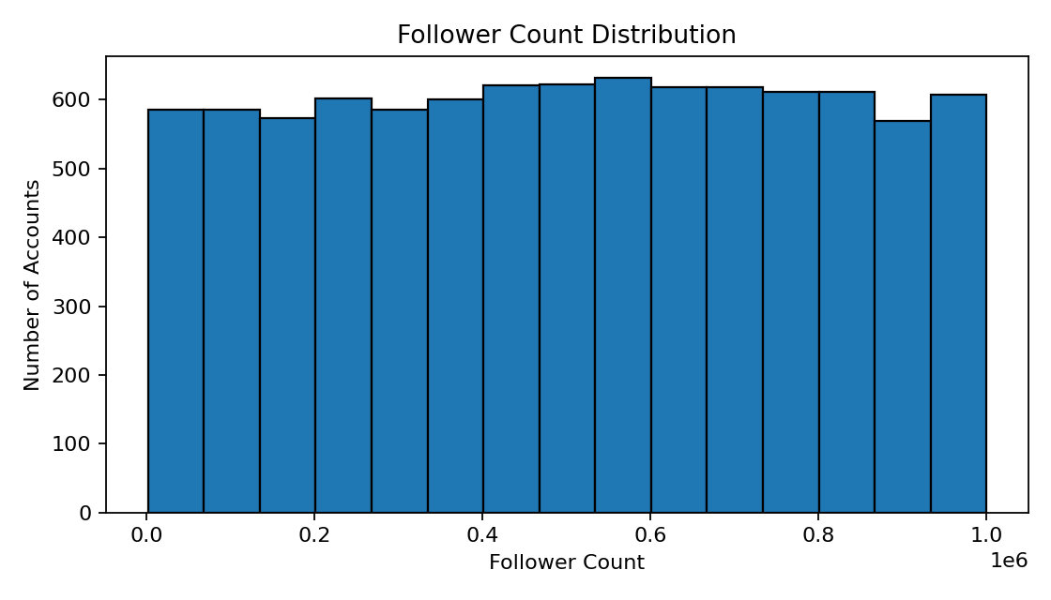
Algorithm – Sheet 4: Campaign Reach by Platform
Chart: Bar chart
1. Create a new worksheet named Sheet 4.
2. Drag Platform to the Columns shelf.
3. Drag Campaign Reach to the Rows shelf.
4. Tableau aggregates Campaign Reach.
5. Select the Bar chart.
6. Apply different colors using Platform.
7. Display campaign reach for different platforms.
8. Compare campaign reach across platforms.
9. Identify platforms with higher or lower campaign reach.
10. Interpret the relationship between Platform and Campaign Reach.
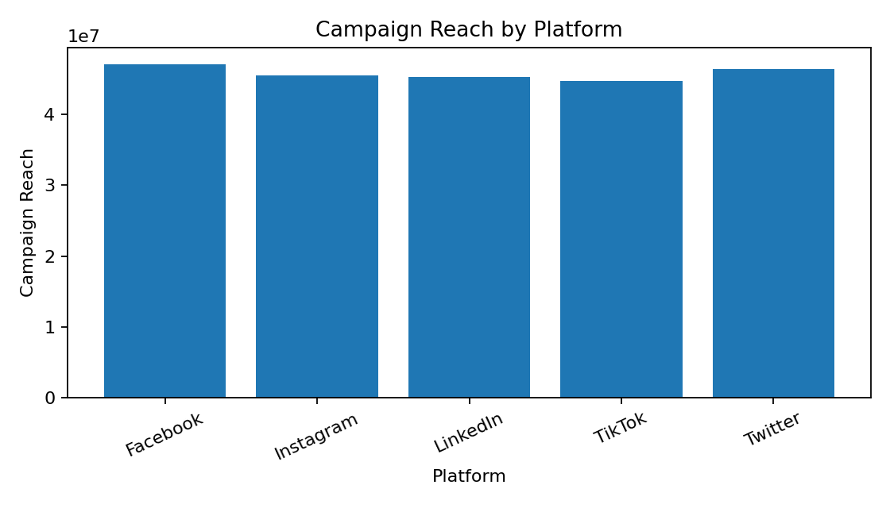
Algorithm – Sheet 5: Ad Spend and Campaign Reach by Platform
Chart: Line chart
1. Create a new worksheet named Sheet 5.
2. Drag Platform to the Columns shelf.
3. Add Ad Spend (USD) and Campaign Reach as measures.
4. Use Measure Names and Measure Values to display multiple measures.
5. Select the Line chart.
6. Apply color based on Measure Names.
7. Compare Ad Spend and Campaign Reach across platforms.
8. Analyze differences between platforms.
9. Identify patterns among Platform, Ad Spend, and Campaign Reach.
10. Use the visualization for social media campaign analysis.
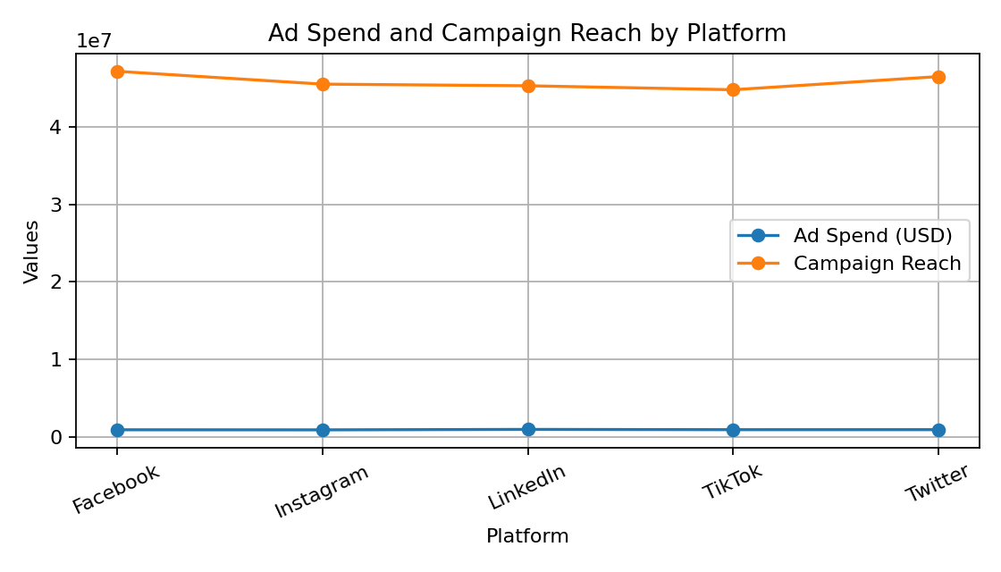

Algorithm – Sheet 6: Engagement Rate by Platform
Chart: Automatic chart
1. Create a new worksheet named Sheet 6.
2. Drag Platform to the Rows shelf.
3. Drag Engagement Rate to the Columns shelf.
4. Tableau calculates the aggregated Engagement Rate.
5. Keep the chart type as Automatic.
6. Display engagement-rate values separately for each platform.
7. Compare engagement rates between platforms.
8. Identify platforms with higher or lower aggregated engagement rates.
9. Add labels or filters if required.
10. Interpret the relationship between Platform and Engagement Rate.
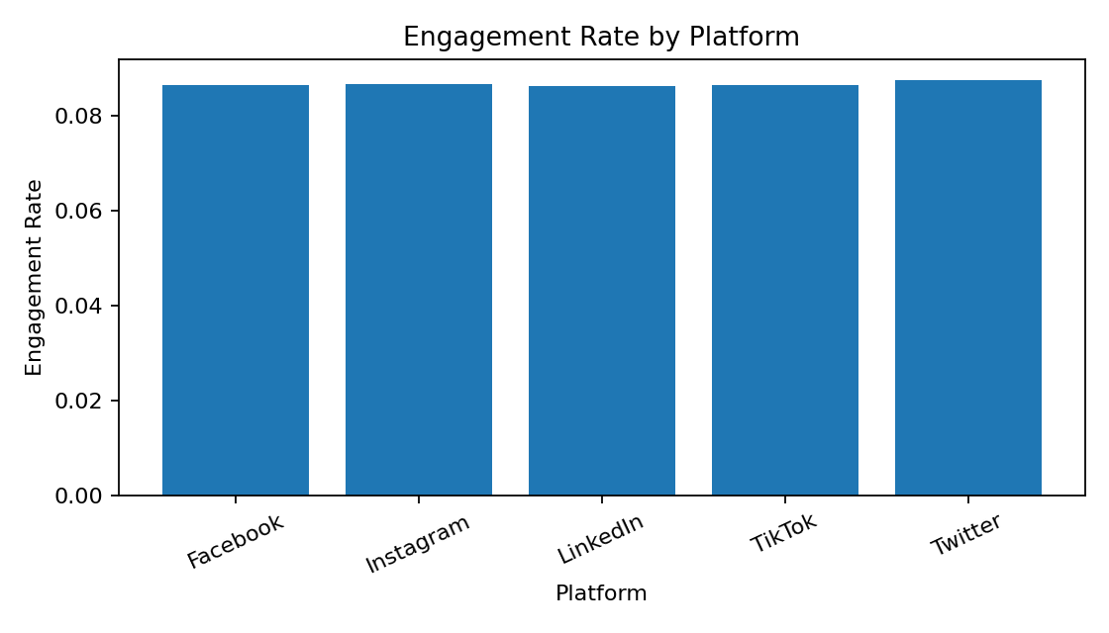
Sample Dataset Fields
Account ID, Username, Platform, Follower Count, Posts Per Week, Engagement Rate, Ad Spend (USD), Conversion Rate, Campaign Reach.
Dataset Summary
Total records: 10016
Platforms: Facebook, Instagram, LinkedIn, TikTok, Twitter
Dashboard
1. Add Sheet 1 – Follower Count by Platform.
2. Add Sheet 2 – Engagement Rate by Platform.
3. Add Sheet 4 – Campaign Reach by Platform.
4. Add Sheet 5 – Ad Spend and Campaign Reach.
5. Add filters such as Platform and Account Type where available.
6. Arrange the visualizations on the dashboard.
7. Add titles, labels, and legends.
8. Save the Tableau workbook.
9. Use the dashboard for interactive social media analysis.

RESULT:
Thus, Tableau was used successfully to connect datasets, create worksheets, apply filters and parameters, generate visualizations, build dashboards, and create stories for business intelligence and analytical decision-making.

